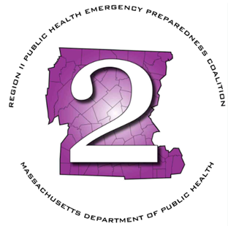
Region 2 Public Health Emergency Preparedness Program (PHEP)

Monthly Meeting Agenda
Thursday, May 7, 2026 at 9am

Virtual:
Microsoft Teams Need help?
Join the meeting now
Meeting ID: 230 086 509 772 4
Passcode: wc69ig3o

Dial in by phone
+1 469-998-7682,,641254411# United States, Dallas
Find a local number
Phone conference ID: 641 254 411#

- Roll Call
- Chairperson's Announcements
- Review minutes: April 2026
- HMCC Sponsoring Organization:
  - FY26 Priority Areas & Budget Updates
    - Purchases
    - Tabletop AAR/IP Submissions
    - Trainings
  - FY27 Priority Areas & Budget
- BME Strategies:
  - CERC Workshops
- MDPH Updates:
  - FIFA Planning
  - FY27 Update
- LSAC Rep Updates
- MRC Updates
- HMCC Rep Updates
- Any additional business
- Next Meeting – June 4th

Executive Session: MGL Chapter 30A (21)(2): To conduct strategy sessions in preparation for contract negotiations with nonunion personnel

