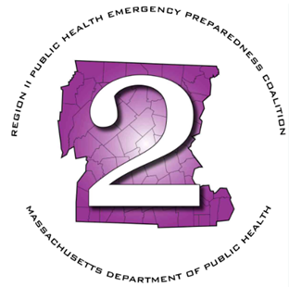
Region 2 Public Health Emergency Preparedness Program (PHEP)

Off-Cycle Steering Committee Meeting
Tuesday, April 28, 2026 at 10am

Agenda

Microsoft Teams meeting
Join: https://teams.microsoft.com/meet/25144033479674?p=bUOfW8vWy1QJcCaXuz
Meeting ID: 251 440 334 796 74
Passcode: eL7zi3au

Need help? | System reference
Dial in by phone
+1 469-998-7682,,174409841# United States, Dallas
Find a local number
Phone conference ID: 174 409 841#

- Roll Call
- Chairperson’s Announcements
- HMCC Sponsoring Organization:
  - Regional Purchase of Portable Hand-Washing Stations
- Next Meeting – May 7th

Executive Session: MGL Chapter 30A (21)(2): To conduct strategy sessions in preparation for contract negotiations with nonunion personnel

