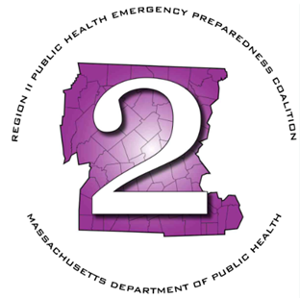
Region 2 Public Health Emergency Preparedness Program (PHEP)
Monthly Meeting Agenda
Thursday, March 5, 2026 at 9am

Virtual via Teams

Join the meeting now
Meeting ID: 230 086 509 772 4
Passcode: wc69ig3o

Dial in by phone
+1 469-998-7682,,641254411# United States, Dallas
Find a local number
Phone conference ID: 641 254 411#

- Roll Call
- Chairperson’s Announcements
- Review minutes: February 2026
- HMCC Sponsoring Organization:
  - FY26 Priority Areas & Budget Updates
    - Budget Modifications
    - Tabletop AAR/IP Submissions
    - Training Updates
    - Satellite Phone Drill – March 18th
    - 2026 MAPHN Conference ( May 13-14 at Springfield Marriott)
    - Crisis Emergency & Risk Communication (CERC) Project & Contractor
- MDPH Updates
  - FIFA Planning
  - FY27 Update
- LSAC Rep Updates
- MRC Updates
- HMCC Rep Updates
- Any additional business
- Next Meeting – April 2nd – In Person

