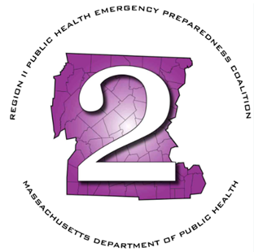
Region 2 Public Health Emergency Preparedness Program (PHEP)
Monthly Meeting Agenda
Thursday, January 8, 2026 at 9am

Virtual via Teams

Join the meeting now
Meeting ID: 230 086 509 772 4
Passcode: wc69ig3o

Dial in by phone
+1 469-998-7682,,641254411# United States, Dallas
Find a local number
Phone conference ID: 641 254 411#

- Roll Call
- Chairman’s Announcements
- Review minutes: December 2025
- HMCC Sponsoring Organization:
  - FY26 Priority Areas & Budget Review
    - Tabletop Exercise Status
    - 2026 NACCHO Conference
    - Risk Communication Project
- MDPH Updates
- LSAC Rep Updates
- MRC Updates
- HMCC Rep Updates
- Any additional business
- Next Meeting – February 5th - Virtually

