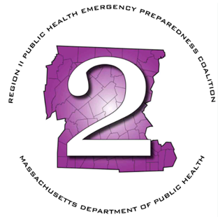
Region 2 Public Health Emergency Preparedness Program (PHEP)
Monthly Meeting Agenda
Thursday, September 4, 2025 at 9am

Online on TEAMS
Microsoft Teams
Join the meeting now
Meeting ID: 230 086 509 772 4
Passcode: wc69ig3o
Dial in by phone
+1 469-998-7682,,641254411# United States, Dallas
Find a local number
Phone conference ID: 641 254 411#

- Roll Call
- Chairman’s Announcements
- Review minutes: August 2025
- HMCC Sponsoring Organization:
  - Priority Area & Budget Review
  - Review Reg 2 Regional Response Plan, Resource Coordination Annex, PH Framework
- LSAC Rep Updates
- MRC Updates
- HMCC Rep Updates
- Any additional business
- Next Meeting – October 2nd – Red Apple Farm 455 Highland Ave, Phillipston, MA 01331

Executive Session: MGL Chapter 30A (21)(2): To conduct strategy sessions in preparation for contract negotiations with nonunion personnel

