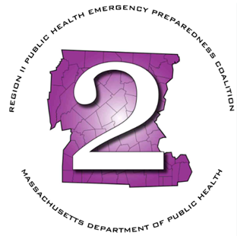
Region 2 Public Health Emergency Preparedness Program (PHEP)
Executive Committee Meeting Agenda
Monday, November 18, 2024 at 11:00am

Virtual:
Microsoft Teams Need help?
Join the meeting now
Meeting ID: 288 968 632 033
Passcode: M2HfTA
Dial in by phone
+1 469-998-7682,,953919817# United States, Dallas
Find a local number
Phone conference ID: 953 919 817#

- Roll Call
- Chairman’s Announcements

Executive Session: MGL Chapter 30A (21)(2): To conduct strategy sessions in preparation for contract negotiations with nonunion personnel

